**Hazardous Materials**

**Release from a Facility**

**Sub Plan**

## Version Control

The Latrobe City Hazardous Materials Release from a Facility Sub - Plan is a sub plan of the Municipal Emergency Management Plan. Major changes to this plan must be approved and authorised by the Municipal Emergency Management Planning Committee (MEMPC).

This document will be reviewed by the Sub Committee annually or after an event. Any changes to the document will be forwarded to the MEMPC for adoption.

The record below is to be completed by the person making the amendment(s).

|  |  |  |  |  |
| --- | --- | --- | --- | --- |
| Version | Page Number | Date | Description | Amended by |
| Draft Version 1 | All | July 2015 | Plan developed | Hazardous Materials Release from a Facility Sub Committee |
| Plan adopted by MEMPC | All | 7 August 2015 | Plan Adopted | MEMPC |
|  |  |  |  |  |
|  |  |  |  |  |
|  |  |  |  |  |

Disclaimer: This work has been compiled from a variety of sources including material generally available on the public record, reputable specialist sources and original material. Care has been taken to verify accuracy and reliability wherever possible. However, the material does not provide professional advice. Latrobe City Council does not give any warranty or accept any liability concerning the contents of this work.

Table of Contents

Version Control 1

Introduction 2

Purpose 3

Part One – Agency Roles 6

Part Two - Latrobe City Staff Arrangements 9

## 

## Introduction

Latrobe City is Victoria’s only eastern regional city, home to 73,929 residents and 5,019 businesses and is the residential and commercial hub of a larger catchment of 262,000 people stretching across the Latrobe Valley and Gippsland region.

We are one of the most economically diverse municipalities in Victoria with local industries generating over $3.7 billion in Gross Regional Product and $8.8 billion in annual economic output. The combination of major employers, the City’s regional significance, and affordable housing make Latrobe City a centre of opportunity for both business and families.

The Hazelwood Mine Fire that began on the 9 February 2014, was the largest and longest burning mine fire that has occurred in the Latrobe Valley to date. The fire was caused by embers spotting into the Hazelwood mine from bushfires burning in close proximity to the mine. The mine fire burned for 45 days. The fire sent smoke and ash over the town of Morwell and surrounding areas for much of that time.

The Hazelwood mine fire constituted two emergencies: a major complex fire emergency and a serious public health emergency.

The impact of the Hazelwood mine fire on the Latrobe Valley community has been significant. People have been affected in many ways. First and foremost, the community has experienced adverse health effects and may be affected for an indeterminate period into the future.

As a result of the Hazelwood mine fire the Latrobe City Municipal Emergency Management Plan identifies that after any significant impact the committee undertakes a risk review.

The risk working group undertook a Community Emergency Risk Assessment in line with this requirement and reassessed the hazardous materials release from a facility risk; this risk has been reclassified as high risk thus identifying the need for a sub plan to be developed.

## Purpose

The intent is to develop a sub plan that is underpinned by a range of services, protocols and practices which are integrated.

The purpose of this plan is to:

* focus on Latrobe City’s role in assisting agencies responding to community concerns and managing the consequences of large, extended or complex events, including the public health impacts of hazardous materials and smoke or emissions exposure
* have a scope that recognises that each extended smoke event is unique, recognising there will be different air pollutants of potential public health risk and a varying spectrum of community concerns
* work with agencies to identify the key potential smoke-related scenarios and other hazardous materials releases and the overarching arrangements for managing the impacts of smoke and other emissions on air quality and community health, particularly for events occurring close to populations.

Examples include:

* an extended smoke event from bushfires
* smoke impacts from large scale planned burns
* a large open-cut coal mine fire
* landfill or waste facility fire (including tyre fires)
* major industrial fires (i.e. chemical plant or warehouse/storage)
* fires, spills or unintended releases or emissions involving hazardous materials

This sub plan builds on the current coordinated “all hazards” approach. It is intended to be complementary and adds a further dimension in terms of managing community expectations and delivering a consistent approach.

The sub plan supports and includes:

* ensuring that the most accurate and relevant information available about air quality measurements, assessments and forecasts from EPA is available to all agencies in the most efficient manner, to allow DHHS to undertake proactive and comprehensive assessments of potential public health risks associated with events in or near communities
* the setting of clear triggers for appropriate actions to be undertaken by emergency services, agencies (i.e. EPA, DHHS) and the community (including workplaces).
* a focus on a coordinated approach within Victoria’s emergency management arrangements revising public health messages so that they are clearer and more action oriented
* knowledge of communities to select the best information delivery mechanism and a means of monitoring sentiment

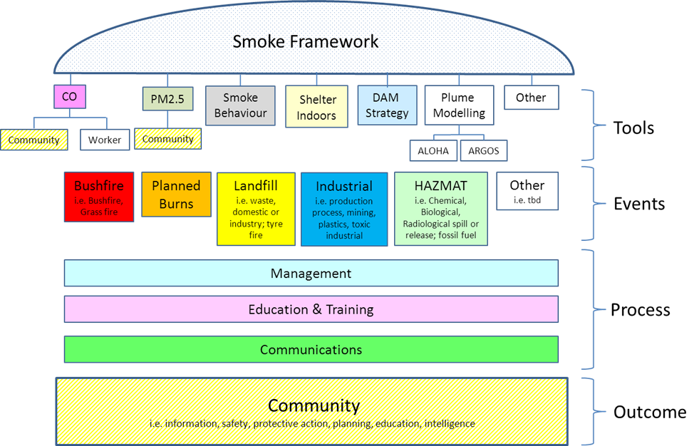

### Prevention/Mitigation Plans/Protocols

The Bushfire Smoke, Air Quality & Health Protocol has been revised to:

* Community Smoke, Air Quality and Health Protocol 2015 and
* includes PM2.5 and PM10 fine particles as air quality monitoring indicators
* reaffirms its application to broad area (i.e. regional) impacts of bushfire smoke on community health
* considering the latest available supporting documents, including the Wildfire Smoke – a Guide for Public Health Officials (California) in this update, and provide a reference for emergency responders
* The State Smoke Framework 2015
* Latrobe City Communications sub plan
* Communication Plan Mine Fire Task Force
* CO standard 2014 – EMV
* Mine Fire SOP - CFA
* Latrobe City MEMP
* Useful links:

<http://oehha.ca.gov/air/risk_assess/wildfirev8.pdf>

<http://www.epa.vic.gov.au/your-environment/air/bushfires-and-air-quality>

<http://www.health.vic.gov.au/environment/bushfires.htm>

## Part One – Agency Roles

### Role of CFA

The Emergency Management Manual Victoria identifies CFA as the:

* Control Agency for:
  + Fire on private land within Country Area Victoria
  + Fire and/or Explosion with Aircraft, Boilers and Pressure Vessels
  + Gas Leakage
  + Hazardous materials Incidents
  + Incidents involving lifts, cranes, scaffolding or amusement structures
  + Rescue involving buildings, structures, lifts, cranes, scaffolding, amusement structures, road, rail, aircraft, industrial, trench or tunnel.

Prevention / Mitigation / Risk Reduction Activities

CFA works to minimize the impact of fires and other emergencies on Victorian communities through prevention, preparedness, education and fire protection activities such as:

* Supporting development of an aware and prepared community
* Development and enforcement of relevant legislation and regulations
* Community development processes to enable communities to deal with emergencies
* Provision of support though information, resources or coordination to other organisations or personnel preparing for or engaging in prevention tasks
* Risk modelling to identify key safety processes and priorities
* Planning and/or providing anything ancillary to the matters listed above.

Response Activities

Rescue of persons endangered by:

* Trenches and tunnels
* Emergency situations generally
* Suppression of uncontrolled fires and explosions
* Control of other dangerous or hazardous situations such as oil, gas and hazardous materials spills
* Protection of property and the environment from fire damage
* Provide advice to threatened and affected communities on actions that they should take during an emergency event
* Support to, and management of, other agencies in the response to emergencies
* Investigation into the causes of fire.

Relief / Recovery Activities

* Provision of assistance and advice to individuals, families and communities who have been affected by fire or other incidents as described above.
* Provide assistance, advice and information to other agencies responsible for, or involved in, recovery activities.

### Part Two - Role of EPA

The Emergency Management Manual Victoria identifies EPA as undertaking the following responsibilities

Prevention / Mitigation / Risk Reduction Activities

* Enforcing of the Environment Protection Act 1970.
* Enforcing the Pollution of Waters by Oil and Noxious Substances Act 1986.
* Training external agencies in the management of hazardous materials incidents.
* Licensing and inspecting industrial facilities.
* Tracking prescribed wastes from generation to disposal.
* Undertaking legal proceedings as appropriate.

Response Activities

* Control agency for pollution of inland waters.
* Assessing the environmental impact of emergencies.
* Determining practical measures to protect the environment.
* Advising the emergency services on the properties and environmental impacts of hazardous materials.
* Ensuring that appropriate disposal methods are adopted for wastes resulting from response activities.

Relief / Recovery Activities

* Assessing environmental impacts of emergencies.
* Ensuring that appropriate disposal methods are adopted.
* Advising affected persons on the properties and environmental impacts of hazardous materials.
* Implementing the Community Environmental Trauma Protocol when required.

#### Department of Human Services

The Department of Health and Human Services is responsible for State and regional co-ordination of emergency relief and recovery.

Prevention / Mitigation / Risk Reduction Activities

* To enhance prevention, preparedness, response and recovery services for a major mass casualty incident or major natural disaster in Victoria.
* Conduct community training and awareness activities (including promoting awareness of safe practices and emergency procedures and implementing safety and warning systems) for relevant clients of the Department of Health and Human Services.
* To develop prevention, preparedness, response and recovery capability across the hospital, primary health and aged care sectors for an emergency with major health consequences.
* Provide whole-of-health leadership and direction in planning and preparing for emergencies with major health consequences.
* Implement legislation, programs and monitoring procedures to minimise public health risk from:
  + infectious diseases
  + contaminated food
  + contaminated water supplies
  + radiation and chemicals.

Response Activities

* Support service delivery by the Department of Health and Human Services and Human Services to affected individuals, groups and/or communities.

Control agency for human disease/epidemics, food/drinking water contamination and incidents involving radiological substances and intentional biological releases.

* Through the State Health Emergency Response Plan, co-ordinate the on-site provision of extended health care including the deployment of Medical Assistance Teams.
* Access additional health professionals for the provision of casualty care during an emergency with major health consequences.
* Direct the strategic health response during an emergency with major health consequences.
* Co-ordinate the deployment of suitably-qualified health professionals in response to an interstate or Commonwealth request.
* Through the State Health Emergency Response Plan, co-ordinate the on-site provision of primary care including the deployment of Field Primary Care Clinics.

Relief / Recovery Activities

* Co-ordinate relief and recovery planning and management at State and regional levels.
* Co-ordinate all aspects of relief and recovery, including State/Commonwealth departments, local government, non-government organisations and agencies.
* Co-ordinate recovery activities in consideration of:
  + The people, social, health and community environment
  + The economic environment
  + The natural environment
  + The built environment.
* Co-ordinate provision of personal support (including psychological first aid) at incident sites and across the community.
* Provide community information and facilitate community redevelopment programs.
* Support councils, Municipal Emergency Management Planning Committees and community recovery committees in relief and recovery planning and managing relief and recovery activities.
* Provide advice, information and assistance to affected individuals, communities, funded agencies and municipal councils.
* Co-ordinate provision of interim accommodation following emergencies with major housing impacts.
* Co-ordinate clean up, together with key support agencies and other organisations with capacity to assist.
* Provide advice, information and assistance to affected individuals, communities, funded agencies and municipal councils.

### Part Three - Role of Latrobe City Council

Local Government is not a lead agency for response and as such supports CFA in this role where possible.

* The Emergency Management Manual Victoria identifies Local Government as undertaking the following responsibilities:
* Prevention / Mitigation / Risk Reduction Activities
* Identification and assessment of hazards/risks.
* Provision of community awareness, information and warning system(s).
* Identification and assessment of risks using a community emergency risk management framework.
* Implementation/coordination of specific risk treatments for identified risks and exposed elements in the community. Including, flood/fire management, maintaining a register of at-risk groups, fire risk reduction (private and council lands)

Response Activities

* Provision of available municipal resources needed by the community and response agencies.
* Establishment of MECC - facilities and staffing.
* Provision of facilities for emergency services’ staging areas.
* Facilitate the delivery of warnings to the community.
* Provision of information to public and media.
* Coordination of the provision and operation of emergency relief (includes catering, emergency relief centres, emergency shelters and material needs).
* Clearance of blocked drains and local roads, including tree removal.
* Support to VicRoads for partial/full road closures and determination of alternative routes.

Relief / Recovery Activities

* Provision of information services to affected communities, using e.g. information lines, newsletters, community meetings and websites
* Provision and staffing of Recovery/Information Centre(s).
* Formation and leadership of Municipal/Community Recovery Committees.
* Post-impact assessment — gathering and processing of information.
* Survey and determination regarding occupancy of damaged buildings.
* Environmental health management — including food and sanitation safety, vector control, such as removing dead animals from waterways.
* Oversight and inspection of rebuilding/redevelopment.
* Provision and management of community development services.
* Provision and/or coordination of volunteer helpers.
* Provision of personal support services, e.g. counselling, advocacy.
* Coordination of clean-up activities, including disposal of dead animals
* Support provision/coordination of temporary accommodation.
* Repair/restoration of infrastructure, e.g. roads, bridges, sporting facilities, public amenities.

## Part Two - Latrobe City Staff Arrangements

Health and safety of staff and the community is the primary concern of this plan.

In the event of an impact occurring Latrobe City will be guided by the Incident Controller as to the health and safety of staff and the community.

Depending on the location of the impact, staffing work locations and arrangements from across the municipality of Latrobe City will be managed on a case by case assessment.

### Communications

Refer to the Latrobe City Emergency Communication Sub Plan where the aim is:

* To provide effective communications during all phases of Emergency Management across all agencies and the community, both internally and externally.