SAMPLE - EMERGENCY MANAGEMENT / EVACUATION PLAN

1.1 Background
Coordinating an event is a complex task, often requiring the participation of many stakeholders, given the complexity of the event, it is vital to maintain good records of the planning, implementation and evaluation process.

Event Management Plans and Evacuation Plans require intricate details specific for each event, and therefore every plan will differ accordingly to the information required.

This Emergency Management Plan / Evacuation Plan (EMP/EEP) is a combination of what is required for an Emergency Management plan, incorporating the Evacuation plan for a specific event.

This Sample Event Management / Evacuation Plan is based on a Council event held at the Latrobe City Sports and Entertainment Stadium and the information contained is based on the specific event and venue requirements, and should only be used as an example.

The plan has been designed as a guide to show how to create a system for protection of life and property in the event of emergencies both man-made and natural that may require the venue to be evacuated. These emergencies include situations such as: - a fire, explosion, bomb threats, chemical releases, stand collapse or other emergency (whether natural or man caused) requiring the movement of people from an area which is believed to be unsafe within the Venue or from the Venue in general to a safe area.

1.1.1 Purpose of the Plan
The purpose of this Plan is to prepare and organise for the venue and event managers, to be able to conduct a time sensitive, safe, secure, orderly and efficient evacuation of the venue, whilst providing an overall view of the event management on site.

Potential emergencies, such as fires, explosions, bomb threats, chemical releases, stand collapse etc. will require some or all of the staff, performers, teams, officials etc and spectators to evacuate the venue or parts of it. The Plan provides guidance for the management, staff and spectators and will minimize threats to life and property.

This plan applies to all potential emergencies at the venue that may require evacuation of staff, performers, teams, officials etc. and spectators to a place of safety. This plan relates to all users of the venue.

1.1.2 Scope
This Emergency Management / Evacuation Plan shall cover those designated actions that venue Management, staff performers, teams, officials etc. and spectators must take in order to ensure a safe and secure evacuation in the event of an emergency.

This extent of the coverage includes the structures within the venue, the perimeter and sporting grounds around the venue and the vehicle car park, either standard or VIP.
The plan is multi hazard in scope and covers both natural and man caused hazards. It will also cover the emergency evacuations of disabled spectators and the structural enhancements to accommodate their movements.

1.2 MISSION STATEMENT
To implement an orderly, safe and organised evacuation of the venue within the required time. (The mission statement of the organisation hiring the venue with be the prime statement for the event.)

1.3 AUTHORITY
This Plan is developed under the authority of Latrobe City Council Event Team and will be executed under the authority of the Emergency Services and Victoria Police.

1.4 CRITICAL ASSUMPTIONS
The critical assumptions are:
- There is adequate signage throughout the venue identifying emergency exits.
- Good Telecommunication systems are in place within the venue.
- Public Address system that can be heard throughout the venue, with loudhailers available for areas not within direct public address range.
- Sufficient staff have been trained and will be located in the sectors/evacuations areas identified.
- Evacuation routes are left clear of any obstruction
- There are considerations for spectators with disabilities
- Venue staff have been well exercised in the evacuation drills for the venue.

  - INSTITUTIONAL FRAMEWORK
The decision to invoke the partial or full evacuation of the Latrobe City Sports and Entertainment Stadium is the full responsibility of the Events Manager, in conjunction with the complex manager on site.

The event manager on site and his /her sub-ordinates (event staff) will form the evacuation team/wardens required to muster spectators, guests and the public to the designated evacuation areas.
The event manger must adopt the venue evacuation plan and ensure adequate staffing to enable the plan to be enforced if required.

The role of the evacuation warden will be to manage the careful evacuation of there designated areas, insuring that all personnel within their allocated areas are escorted to their allocated evacuation sites in a safe and timely manner. Ensuring all patrons/participants/spectators and staff are accounted for.

All patrons to be advised through the public address system or by loud hailer of the need to proceed to the nearest safe designated assembly area and remain there until such time as further instruction is given by the event manager. (Assembly areas to be marked on site plan, in specific event’s event management plan).

In the case of an evacuation, the event manager will liaise with Victoria Police and other emergency services agencies as required.

1.6 CONCEPT OF OPERATIONS
Once an evacuation has been called by the venue manager or event manager, the emergency evacuation wardens will make their way to their allocated area which include:
Area 1 | Internal building – internal entertainment areas, change rooms and other complex areas.  Evacuation site 1 – Asphalt car park area, access via facility main entrance doors
Area 2 | Complex viewing standing area  Evacuations Site 1 – Asphalt car park area, access via exit 2
Area 3 | Main Grand Stand  Evacuations Site 2 – to the east of the Don Di Fabrizio grand stand.
Area 4 | Main Soccer field  Evacuation Site 1 – Asphalt car park, access via exit 2.
Area 5 | Soccer field surrounds southern  Evacuation Site 1 - Asphalt car park, access via exit 2.
Area 6 | External soccer fields to the east of the main grand stand and north of main soccer field.  Evacuation Site 2 – to the east of the Don Di Fabrizio grand stand.

The event Public Address Announcer will make their way to the public address system to make the appropriate announcements. The wardens are then to assist with the evacuation of their allocated areas to the designated evacuations sites.

Evacuation Site 1
The asphalt internal car park area for all patrons in Area 1 -the internal buildings/club rooms area. Area 4 – viewing area part of main entertainment facility & Area 5 - south of Main Field. These patrons will be evacuated through Gate 3, main entrance when it is safe to do so. If the number of patrons exceeds the capacity exiting to the south of the grounds, the alternative gate 4 will be used to evacuate personnel.

Evacuation Site 2
For all patrons in the grand stand and north of main field – Areas 6 & 7 of the ground to be directed to the second soccer field area to the east of the Don Di Fabrizio Grand Stand.

All patrons will be evacuated from evacuations site 2 thought Exit 1 south end of the ground. The turnstile entrance gates will be used as alternative evacuation points should entrance 1 be blocked.

Consideration must be given to:
- The characteristics of the hazard or threat; the magnitude, intensity, speed of onset, duration and impact on the venue.
- The number of people to be evacuated, the time available, the distances to travel in order to affect a safe and secure evacuation of the site are key to this section.
- The use of signage and lighting along with other electronic aids to support the evacuation.
- The provisions for carrying out a complete or partial evacuation of the people are addressed.
- The areas likely to be evacuated are defined.
- The travel/evacuation routes are specified and the destination of evacuees is identified.
- The approach for transporting and controlling the flow of evacuees from the threatened venue to the Assembly Area and their re-entry procedures are outlined.
- Access and egress for those with a disability, would be to Evacuation Site 1, Asphalt car part with egress through exits 2 and 3.

1.7 EMERGENCY OPERATIONS
- Should a serious incident occur at the venue that required the facility to be evacuated, the Victoria Police are to be advised immediately of the incident, and asked to respond to the emergency and assist with the evacuation.
- Ambulance and other emergency services are to be contacted immediately as the need for their services have been identified. Ambulance access with be through main exit 2.
- Interoperability of the response agencies; evacuating the affected spectators safely to the assembly area; monitoring and evaluation of the incident; is the responsibility of the event manager on site.

  - ADMINISTRATION & LOGISTICS
- The event manager is responsible for the administrative and logistic requirements for successfully executing the Emergency Evacuation Plan.
- It is the responsibility of the event organizer/manger/hirer of the facility to familiarise themselves with the evacuation plan, and ensure that they have the correct number of emergency wardens, who have been trained in the evacuation plan and procedures for this venue.
- Any additional security staff engaged for events will form additional support for the allocated emergency wardens, assisting with the evacuation, It is the responsibility of the event manager to ensure that the evacuation plan has been distributed to the necessary personnel.
- It is the responsibility of the venue manager to ensure copies of the venue evacuation plan has been provided to the event manager, and they have been advised of their responsibilities.
- The event manager & on site venue manager to ensure that evacuation areas are kept clear at all times.

1.9 PLAN DEVELOPMENT & MAINTENANCE
- The venue manager is responsible for coordinating revisions of this Emergency Evacuation Plan, keeping its attachments/maps current and ensuring that standard operating procedures and other necessary implementing documents are developed.
- The Evacuation Plan forms part of an overarching Event Management Plan and will be annually reviewed by Latrobe City Council.
- As Council’s Event Planner is updated, any new requirements will be incorporated into this plan.

2.0 SUPPORT DOCUMENTS
- This document should be read in conjunction with the Municipal Emergency Management Plan.
- The priority in an emergency is to provide timely support to the affected community and to ensure the social and economic impact is minimised. Latrobe City Municipal Emergency management Planning Committee have prepared a Municipal Emergency Management Plan (PDF, 1MB) in accordance with the requirements of the Emergency Management Act 1986.
- The Gippsland Emergency Relief Centre Standard Operating Procedures
1.10 LATROBE CITY SPORTS & ENTERTAINMENT STADIUM EVACUATION PLAN
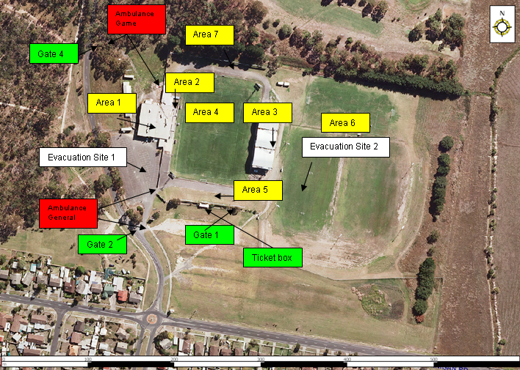
Gate 3

Once an evacuation has been called by the venue manager or event manager, the emergency evacuation wardens will make their way to their allocated area which include: Internal building – internal entertainment areas, change rooms and other complex areas.
Evacuation site 1 – Asphalt car park area, access via facility main entrance doors
Area 2 Complex viewing standing area
Evacuations Site 1 – Asphalt car park area, access via exit 2
Area 3 Main Grand Stand
Evacuations Site 2 – to the east of the Don Di Fabrizio grand stand.
Area 4 Main Soccer field
Evacuation Site 1 – Asphalt car park, access via exit 2.
Area 5 Soccer field surrounds southern
Evacuation Site 1, Asphalt car park, access via exit 2.
Area 6 External soccer fields to the east of the main grand stand and north of main soccer field.
Evacuation Site 2 – to the east of the Don Di Fabrizio grand stand.
The event Public Address Announcer will make their way to the public address system to make the appropriate announcements.
The wardens are then to assist with the evacuation of their allocated areas to the designated evacuations sites.
Evacuation Site 1 The asphalt internal car park area for all patrons in Area 1 -the internal buildings/club rooms area. Area 4 – viewing area part of main entertainment facility & Area 5 - south of Main Field. These patrons will be evacuated through Gate 3, main entrance when it is safe to do so. If the number of patrons exceeds the capacity exiting to the south of the grounds, the alternative gate 4 will be used to evacuate personnel.
Evacuation Site 2 For all patrons in the grand stand and north of main field – Areas 6 & 7 of the ground to be directed to the second soccer field area to the east of the Don Di Fabrizio Grand
Stand. All patrons will be evacuated from evacuations site 2 thought Exit 1 south end of the ground. The turnstile entrance gates will be used as alternative evacuation points should entrance 1 be blocked.

