SITE PLAN - JAPANESE DAY 2007 – SATURDAY 14 OCTOBER - KERNOT HALL, MORWELL

Evacuation
Point 2
(over bridge)
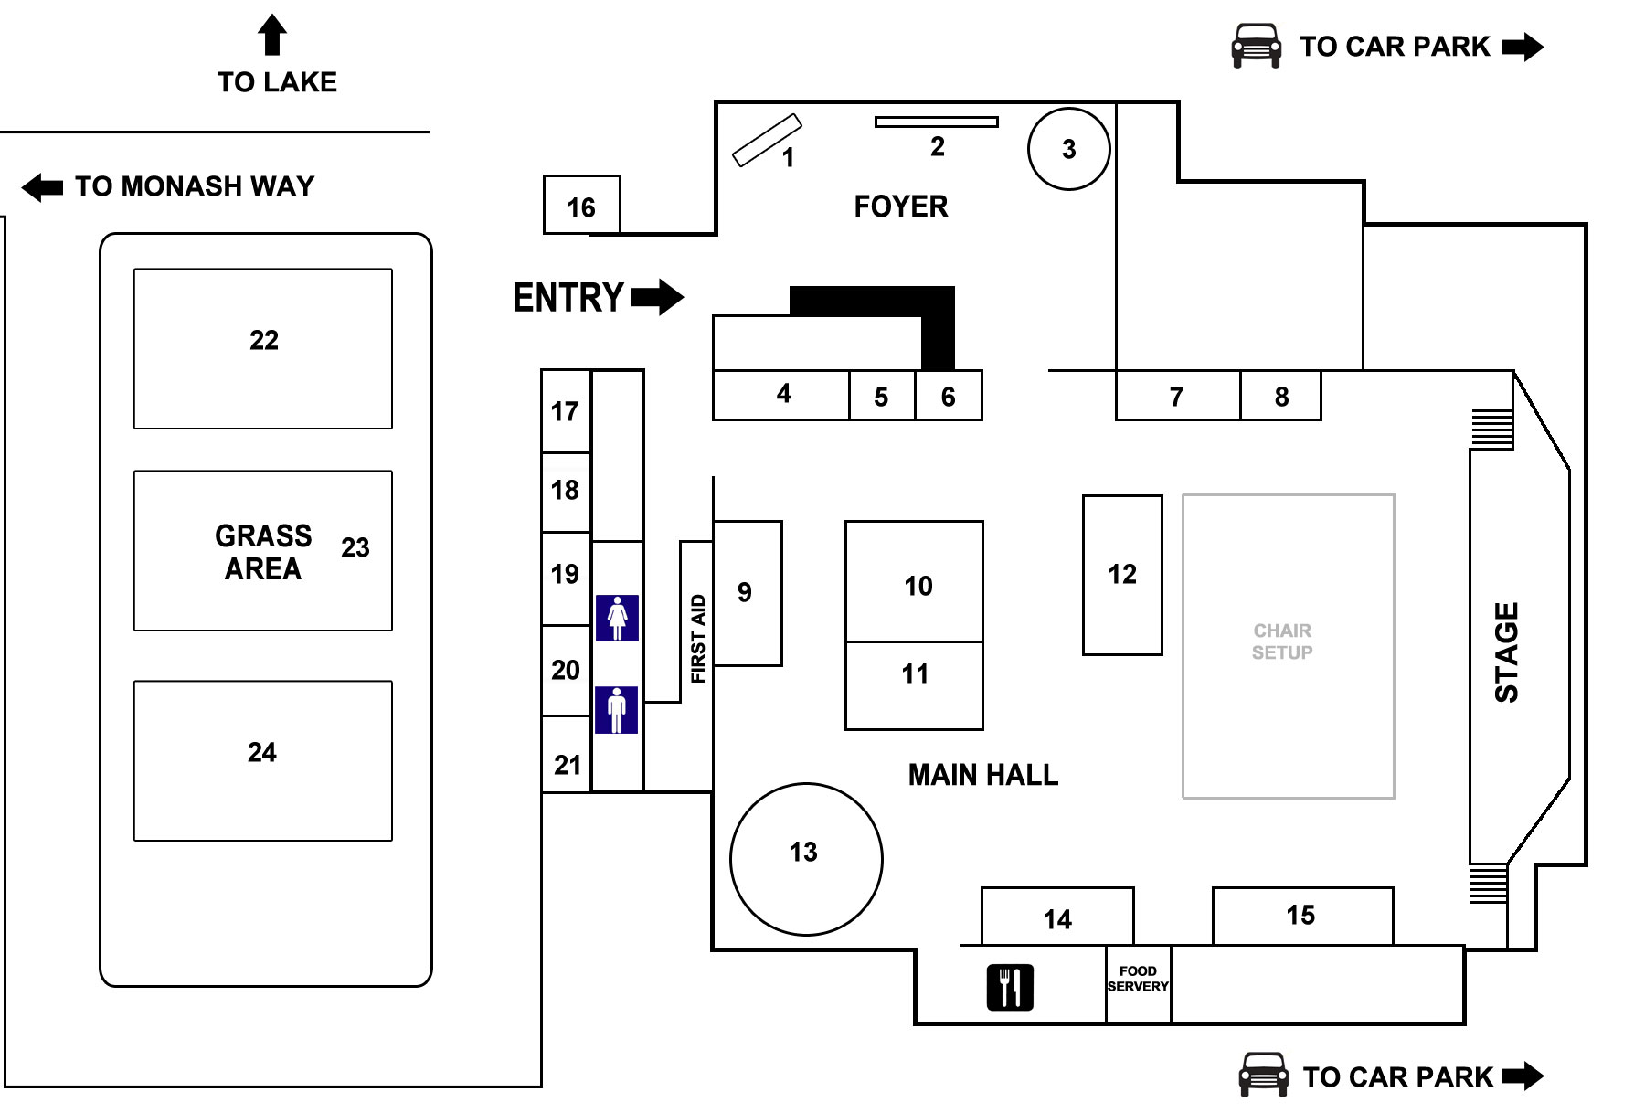
Evacuation Point 1
(carpark)
Road closure
Road closure
A
Ambulance bay

