Planning and Environment Act 1987

LATROBE PLANNING SCHEME

Notice of the preparation of an amendment to a planning scheme

Amendment C152latr

Overview

This amendment seeks to rezone approximately 57.44 hectares (ha) of rural land for urban purposes. The amendment proposes to rezone approximately 1.38ha of land to the Commercial 1 Zone, whilst the balance of the site is proposed to be rezoned to the General Residential Zone – Schedule 3, consistent with the intentions of the Morwell to Traralgon Structure Plan. Amendments to the Commercial 1 Zone Schedule are proposed - setting a maximum leasable floor space of 1,200m² for a Shop. The Development Plan Overlay is proposed over the entire site to facilitate the orderly and efficient future development of the land.

The amendment also proposes to apply the Environmental Audit Overlay to the south-east corner of the land to ensure that further investigations and, if necessary, remediation works are undertaken prior to the approval of a potential sensitive use. For further details, refer to the explanatory report about the amendment.

Details of the amendment

The Latrobe City planning authority has prepared Amendment C152latr to the Latrobe Planning Scheme.

The land affected by the amendment is 5483 and 5495 Princes Highway, Traralgon, see Figure 1.
The subject land is comprised of three allotments formally described as Lot 1 TP823034F (as contained in Volume 10143 Folio 075), Lot 1 TP954239D (as contained in Volume 11488 Folio 318) and Crown Allotment 41D of TP897605U (as contained in Volume 09516 Folio 324).
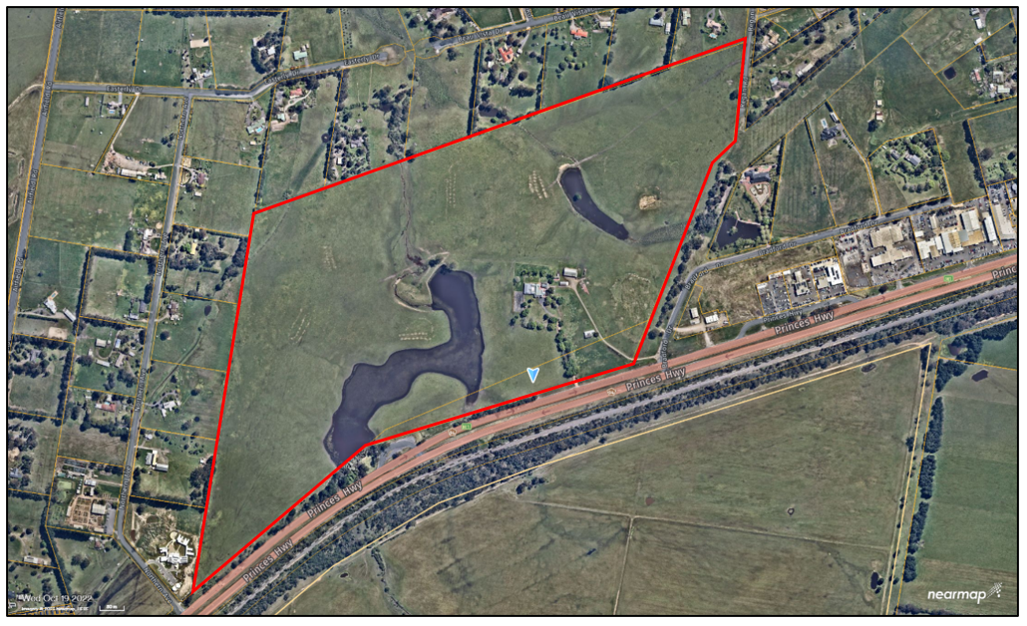
Figure 1: Area subject to amendment. Source: Near Map

The amendment proposes to:
- Amend Planning Scheme Map No. 85 to rezone 1.38ha of the south-east corner of the subject land from Farming Zone Schedule 1 (FZ1) to Commercial 1 Zone (C1Z).
- Amend Planning Scheme Map Nos. 53 and 85 to rezone 56.06ha of subject land from Farming Zone Schedule 1 to General Residential Zone Schedule 3 (GRZ3).
- Insert new Planning Scheme Map No. 53DPO and amend Planning Scheme Map No. 85DPO to apply the Development Plan Overlay Schedule 12 to the subject land
- Insert new Planning Scheme Map No. 85EAO to apply the Environmental Audit Overlay to part of the subject land.
- Amend the Schedule to the Commercial 1 Zone to establish a ‘maximum leasable floor area for a Shop’ of 1,200 m² for the subject land.
- Insert a new DPO12 Schedule to the Development Plan Overlay to guide orderly use and development of the subject land.
- Amend Clause 02.04 (Strategic Framework Plans) to include 5483 and 5495 Princes Highway, Traralgon as ‘Residential Supply’ on the Morwell to Traralgon Framework Plan.
- Amend Clause 11.03-2L (Morwell to Traralgon Structure Plan) to include 5483 and 5495 Princes Highway, Traralgon as ‘Residential Supply’ on the Morwell to Traralgon Structure Plan.
- Amend Clause 16.01-1L (Housing Supply) to insert a new Housing Framework Plan for Traralgon West to identify 5483 and 5495 Princes Highway, Traralgon as Limited Change.
- Amend Clause 72.03 (What does this Planning Scheme Consist of?) to include new planning scheme maps in the Latrobe Planning Scheme.
- Amend Clause 74.01 (Application of Zones, Overlays and Provisions) to amend where the application of the Commercial 1 Zone should apply to.
- Amend Clause 74.02 (Further Strategic Work) Schedule to recognised additional strategic work in Traralgon West.

You may inspect the amendment, any documents that support the amendment and the explanatory report about the amendment, free of charge, at:

- the Department of Transport and Planning website www.planning.vic.gov.au/public-inspection or by contacting 1800 789 386 to arrange a time to view the amendment documentation.

- the Latrobe City Council’s website at https://www.latrobe.vic.gov.au/Property/Development/Planning_Scheme_Amendments/Current_Planning_Scheme_Amendments; and/or

- during office hours, at the office of the planning authority

Latrobe City Council
Corporate Headquarters
141 Commercial Road, Morwell
Office hours: 9am to 5pm, Monday to Friday

Churchill Service Centre
9-11 Philip Parade, Churchill
Office hours: 8:30am to 12noon and 1pm to 5:15pm Monday to Friday

Moe Service Centre
1-29 George Street, Moe
Office hours: 8.30am to 5.15pm Monday to Friday and 9am to 12noon Saturday

Traralgon Service Centre
34-38 Kay Street, Traralgon
Office hours: 8.30am to 5.15pm Monday to Friday and 9am to 12noon Saturday

Any person may make a submission to the planning authority about the amendment. Submissions must be made in writing giving the submitter’s name and contact address, clearly stating the grounds on which the amendment is supported or opposed and indicating what changes (if any) the submitter wishes to make.

Name and contact details of submitters are required for the planning authority to consider submissions and to notify such persons of the opportunity to attend planning authority meetings and any public hearing held to consider submissions.

The closing date for submissions is 30 June 2026. A submission must be sent to Latrobe City Council by:

Mail: Latrobe City Council, PO Box 264, Morwell, VIC, 3840, or
Email: Latrobe@latrobe.vic.gov.au – Attention: Strategic Planning Department

The planning authority must make a copy of every submission available at its office and/or on its website for any person to inspect free of charge until the end of the two months after the amendment comes into operation or lapses.

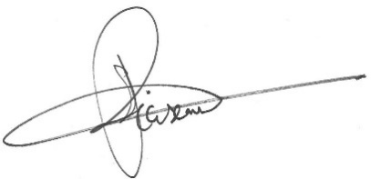
STEVEN PIASENTE
Chief Executive Officer

