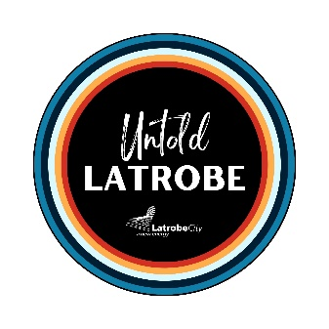

Untold Latrobe – Submission Form

Untold Latrobe is a project designed to connect us to the place we live and build community pride through inclusive and place-based storytelling. We want to celebrate your individual histories to show how our people and places come together to make not just our town, but our community, our present, and our future.

Your Untold Latrobe stories will be displayed on colourful markers and placed around town and will reflect your memories, no matter how small they may seem. It could be something as simple as ‘this is where my grandfather took me for my first ice-cream’ or ‘this is where I first came out to my best friend’. Your memory might help someone else feel welcome or learn more about their neighbours.

Write your message here:

_________________________________________________________________________________________________________
_________________________________________________________________________________________________________
_________________________________________________________________________________________________________
Please keep your message as short as you can – a sentence or two. We will transfer these messages on to stickers and post them around Traralgon. We will not post anything that could cause harm to others.

The location where it occurred:
Number: _________________________________________________________________________________________________
Street Name: ____________________________________________________________________________________________
Building / Landmark: _____________________________________________________________________________________

Want more information or some help to complete a sticker?
Just ask one of our library staff or contact us at libraryevents@latrobe.vic.gov.au or 1300 367 700 [please ask for Georgia Karavis]. You can also send through your submission via email to the above address, subject line ‘Untold Latrobe Entry’, with a short message and address as above, until 10 July 2022.

